**15B17CI471 Algorithms &Problem Solving Lab**

**Lab Test – 2 Friday 2:30 PM – 4:15 PM**

**Set - A**

Q1. Given a square matrix, print the maximum length snake sequence in it. A snake sequence is defined as a sequence of numbers where each new number, which can only be located to the right or down of the current number, is either plus or minus one.

For example, we can either move right from any cell in the matrix (if that number is ±1) or move down (if that number is ±1). The problem is finding the longest path (snake sequence) through the matrix, keeping in mind that we can only move to a new cell whose value is ±1 concerning the current cell.

For example, the maximum length snake sequence of the following matrix is 5 — 4 — 5 — 6 — 7 — 8 — 7 — 6 as highlighted below:

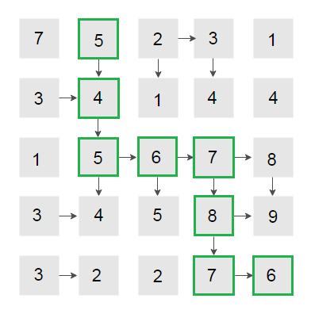

Please note that multiple maximum length snake sequences can exist in the matrix. For example, 3 — 4 — 5 — 6 — 7 — 8 — 7 — 6 is another maximum length snake sequence in the above matrix.

**Set - B**

Q2. An island is in the form of a square matrix, and a person is standing inside the matrix. The person can move one step in any direction (right, left, top, down) in the matrix. Calculate the probability that the person is alive after walking n steps on the island, provided that the person dies on stepping outside the matrix.

For example,

**Input:** 2 × 2 matrix  
The starting coordinates is (0, 0)  
The total number of steps is 1  
   
**Output:** The alive probability is 0.5  
   
   
**Input:** 3 × 3 matrix  
The starting coordinates is (1, 1)  
The total number of steps is 1  
   
**Output:** The alive probability is 1  
   
   
**Input:** 3 × 3 matrix  
The starting coordinates is (0, 0)  
The total number of steps is 3  
   
**Output:** The alive probability is 0.25